**USER'S MANUAL**

**TABLE OF CONTENTS**

Page #

1. General Information 1
   1. System Overview 2
   2. System Category 3
   3. Operational Status 4
   4. Environment 5
   5. User Types 6
   6. Point of Contact 7
      1. Information 8
      2. Coordination 9

1.7 Organization of the Manual 10

1. System summary 11
   1. System Configuration 12
   2. 13
2. Getting Started 14
   1. System Menu 15
      1. Web Application 16

3.1.2 iOS Application 17

1. Using the System 18

# GENERAL INFORMATION

# GENERAL INFORMATION

* 1. **System Overview:**

This is a multi-platform system which requires an active internet connection and also an iOS device to work. This application allows a student to mark his attendance for a particular session and also allows the instructor to view the total attendance of the student. The main functionality of this application works on the displaying and scanning of the QR code. Displaying of the QR code is done on a web page and the scanning of the QR code is done in an iOS application which will be installed in the device of a student for marking his attendance.

The name of the system STUDENT ATTENDANCE TRACKING itself states that the application tracks the complete attendance of the student. **Code Green** team members are mainly responsible for all the functionalities and the changes in this application.

* 1. **System category:**

The system is mainly categorized in to two applications

1. *Major application:* In this application the student using this application scans the QR code and marks his attendance. This QR code is generated by the instructor using a web application.
2. *General support system:* This system also supports different features such as checking the attendance of different sessions for a student and also allows the instructor to change or mark a specific student attendance at any point of time. Student can also check his attendance percentage for the overall sessions conducted and the total number of sessions attended by the student.

**1.3 Operational status:**

This system is Operational, yet still requires some more functionalities to be added in the application for a complete user satisfactory interaction.

**1.4 Environment:**

This system requires an active internet connection to work along with an iOS device and a laptop for generating the QR code for an instructor.

This system currently works on the iOS version 10.

**1.5 User Types:**

|  |  |  |  |
| --- | --- | --- | --- |
| User type | Description | Number of users who can have this permissions | Access |
| Instructor | Instructor is the type of user who is capable of displaying the QR code and checking the attendance of the student. | There can be multiple users named as Instructors in an organizations based on the total number of courses in that particular stream. | 1. Capable of generating the QR code 2. Capable of marking or changing the attendance 3. Capable of checking the total percentage of any individual student of his class 4. Generate the QR based on his own settings |
| Student | Student is a general user of the system who is capable of scanning the QR code using his iOS application and check if his attendance is being marked or not. | There can be multiple users named as Students in an organization. | 1. Capable of scanning the QR code generated by the Instructor 2. Capable of checking his attendance percentage 3. Capable of checking the class in which his attendance has not been marked |
| Admin | Admin can be referred as a Head of the Department of an organization who can access the complete application. | There will be only one admin for a particular department in an organization who can access all the details of the Student as well as the Instructor. |  |

* 1. **Point of Contact**

**1.6.1 Information**

Point of Contact:

1. Team Lead: Sirisha Vanamali.

Contact details: +1-(816) 572-0595

E-mail address: vanamalisirisha@gmail.com

1. Developer: Vamsi Devalla

Contact Details: +1-(660) 541-0439

E-mail address: vammichanti40312@gmail

3 Developer: Rohith Babu Sadhu

Contact Details: +1-(660) 528-0926

E-mail address: rohithbabusadhu@gmail.com

4 Developer: Sai Ram Mamidala

Contact Details: +1(704) 699-4107

E-mail address: srkmamidala@gmail.com

* + 1. **Coordination**

As of now this project is restricted only for the Northwest Missouri State University.

* 1. **Organization of the Manual:**

This manual contains X sections in which the total description of the system is clearly explained with all the functionalities and also the procedures and precautions for using this application in order to use the total functionalities in a successfully.

In section 1 of this manual we discussed about the general description of the project and the users who are capable of using this project and also the functionalities and the access permissions of the users which specifies how deep can a specific user use this system.

In section 2 we mainly discussed on the summary if the system explaining the configuration required for the application to work, discussion on the flow of the data, different access levels of the users and also alternate mode of the system to operate.

In section 3 we have focused on the sequence of steps for any user to follow so that he can use all the functionalities of the application, specifying the different tabs in the iOS application and also different pages associated with the web application with some of the screenshots of the system.

In section 4 we concentrated on the risks and the limits of the system. Also discussing about some of the troubleshooting techniques for a user to successfully overcome any difficulties faced while running the application.

**System Summary**

**System Summary**

**System Configuration**

For Students Attendance Tracking system to work there are some specific configurations required.

There are mainly two different platforms like the web application and the iOS application.

Web application:

Hardware: A laptop and an iOS mobile with active internet connection

Softwares: node.js; Chrome or any responsive browser;

Data Flow:

Executing a project considering the input fields from the user and obtaining the outputs accordingly can be done in a two tier architecture. In this the user directly interacts with the database and retrieves all the necessary information required. Similarly Student attendance tracking is also a two tier architecture, in which the instructor can retrieve the details of the student directly from the database without any further request whereas student can also have a look at the attendance percentage and all the other features directly in the application.

Student

Database

Instructor

Data initially flows from the instructors view to the database which is reflected to the student similarly the data which is obtained by scanning the QR code also goes to the database and reflects in the instructors view displaying the attendance for the student.

**User Access Level:**

For tracking any student’s attendance mainly we require two users such as the instructor and the other user would be a student. There two users play a key role since they are inter dependent on each other to work successfully.

User 1 (Instructor):

Capable of**:**

The instructor is capable of creating a QR code

Capable of adding new Courses

Deleting Courses

Managing the Attendance of the students such as changing them

Restricted to:

Changing the password of his account

Marking excused absence

Accessing the Database

User 2 (Student):

Capable of:

Scanning the QR code Generated

Registering the new courses in one click

Viewing the attendance percentage

Viewing the course details

Persistent login

Restricted to:

Scan QR code from an acute angle

Accessing the database

Log out of the application

Only the maintenance department people are capable of logging into the system as both instructor and student, they can also access the database for assistance and safety. This is the only other mode of logging into the system other than instructor and the student who have registered into the system.

**Getting Started**

**Getting Started**

This section allows the user to have a brief idea of how the overall system works from the starting of the application to closing the application, which includes all the process from signing up, data flow to logging out of the system successfully without any bugs or any difficulties.

**Logging On:**

This is a multiplatform application thus this has entirely different login criteria for both the web and the iOS application. For accessing the system initially the instructor as the user needs to enter the URL of the application i.e <http://student-attendance-tracking.herokuapp.com> and then the user finds an option to sign up or login to his existing credentials. For signing up to the system the user to fill the specific fields specified in the registration form which is displayed ince the user clicks on the sign-up button in the login page below the login button. Once the user registers for the web application then he is free to login with the same credentials which he user for registering his account in to the application. User has to specify the user name and the password as instructed and click on the log in button to perform any further functionalities of the application.

Coming to the iOS application which allows the user to have persistent login i.e the user does not login into the system every time he opens the system, he has the advantage of logging into the system just once at the time of installing the application in the device. Once the user opens the application it displays a form which asks the user to enter the username and the password for the application and then he has to click on the login button for further steps. If the user has not yet been registered in to the system then he also has an option to register his account by clicking the signup button and fill out the form with all the mandatory fields and remember the username and password for logging in.

**MAKE SURE TO REMEMBER THE PASSWORD OF THE APPLICATION, WE CANNOT RETRIEVE THE PASSWORD UNLESS OR UNTILL WE CONTACT THE MAINTAINENCE DEPARTMENT FOR ASSISTANCE**

**SYSTEM MENU:**

**Home:**

As soon as the instructor enters in to the application he finds a page similar to that of the fig.1 which is the home page of the web application, in this page it displays all the courses which are thought by the instructor and it also displays the image of that particular course with the CRN of the course and this page also has different buttons to navigate to the pages like add course (which allows the instructor to add new course to his module), Remove course (which allows the instructor to remove a particular course), QR tab which allows the user to create a new QR for a particular course at that particular time for the students to scan and mark their attendance, profile tab which shows the particulars of the instructor logged in and also a log-off buttons which directly logs the user off the system.

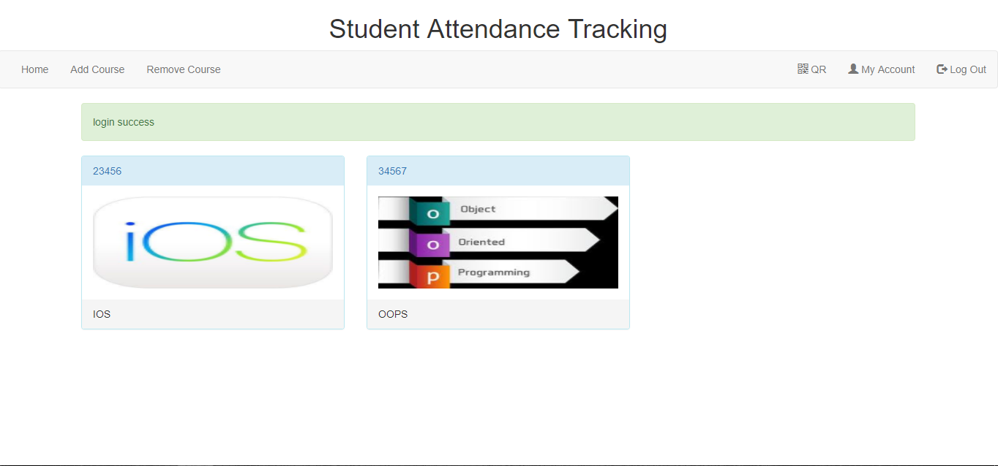

**Add Course:**

Clicking this button navigates the user to another new page in which the user has the freedom to create a new course of his own, which he would be teaching for that particular semester. This page has another menu which allows the instructor to select a particular course of the listed courses which are included in that department, then he is capable entering a new CRN for his particular section, he can also add a description for that particular course specifying, the use of the course, description of the course which he wanted his students to know, then finally click add course button to register the course to his list of courses.

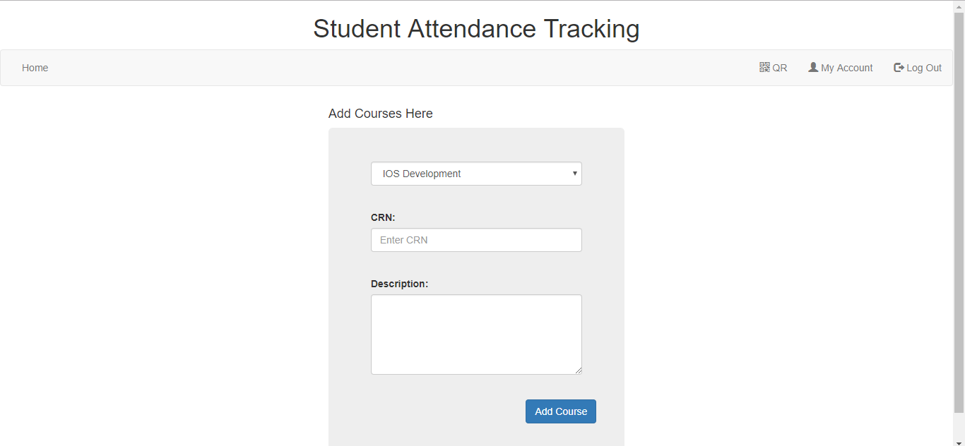

**Remove Course:**

This button navigates the user to remove course page in which the instructor can remove a particular course by selecting the CRN of that particular course and then later on submit the remove course button.

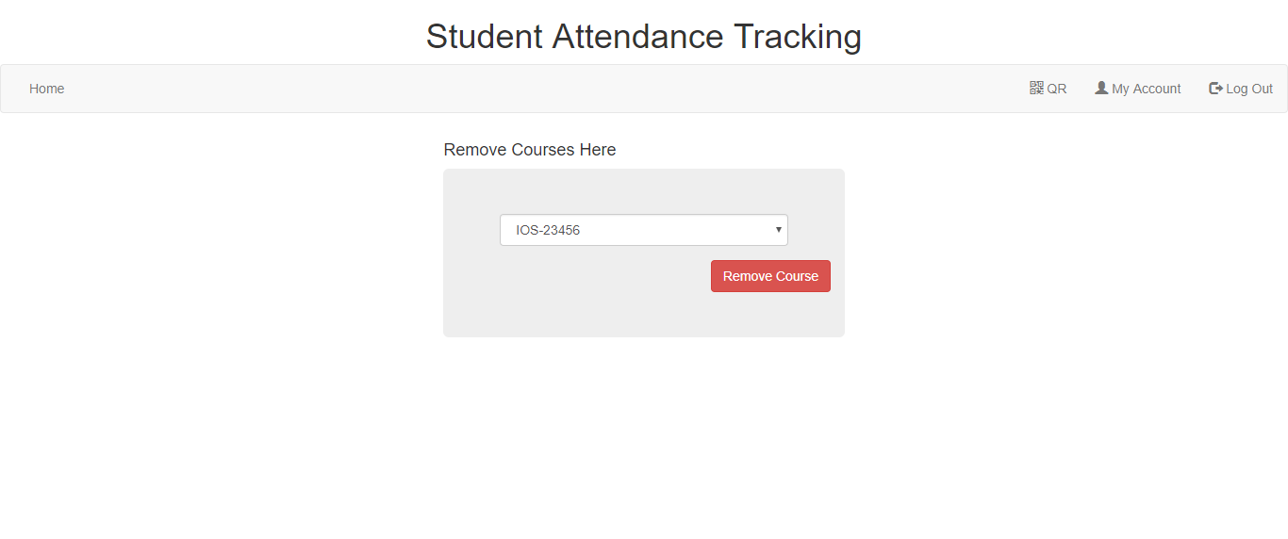

**QR:**

This button navigates the user to the QR generation page in which the instructor can generate the unique QR for a particular course by selecting the CRN of that course and then generate a random number for the QR to be unique and press the generate QR button. This creates a new QR for that particular course at that particular instance of time but the instructor has the option of selecting if he wanted to submit that QR for marking the attendance or not, for which he needs to click on the submit for attendance button in order to display the QR code in a new page bigger and brighter for the students to scan the QR code.

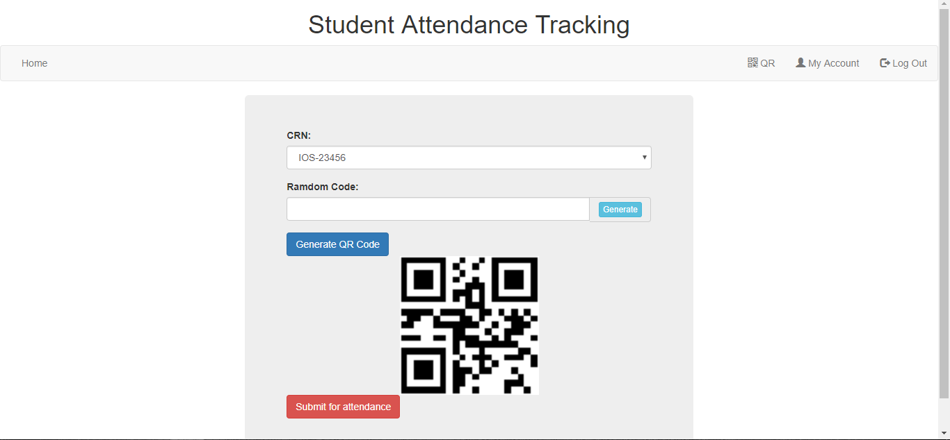

**My Account:**

This page displays all the information of the instructor logged in, it displays the details such as username, ID of the instructor, First name, Last name, e-mail ID, and contact number.

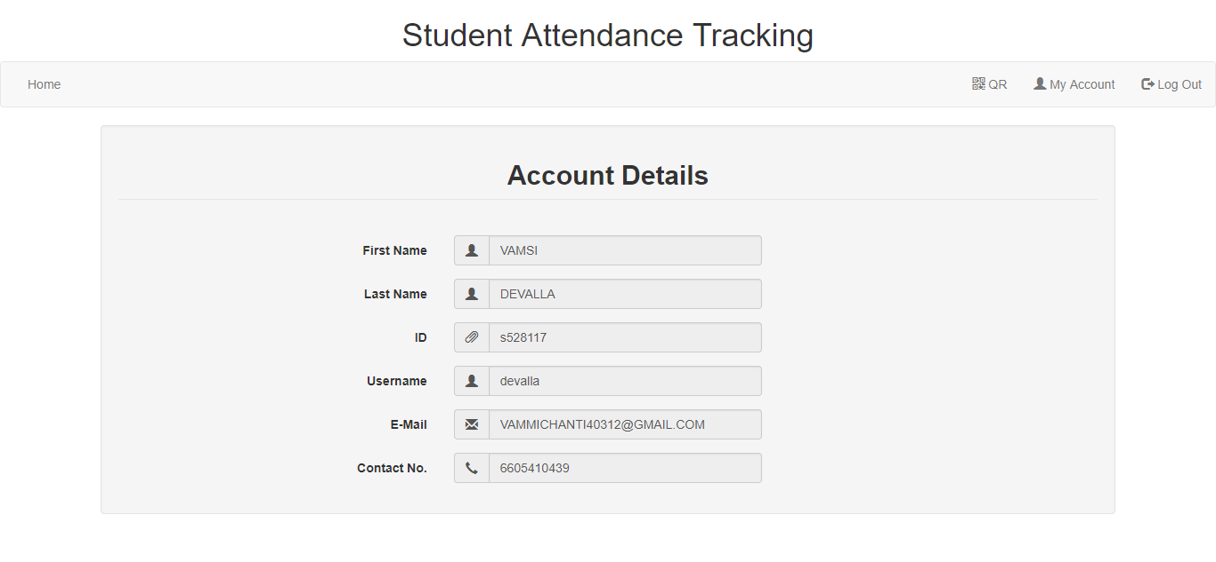

**Log out:**

As soon as the user clicks on the log out button this navigates the user to a page closing the session and displaying a feed as the user has successfully logged out of the system and also a click here button if he wants to log in to the system again.

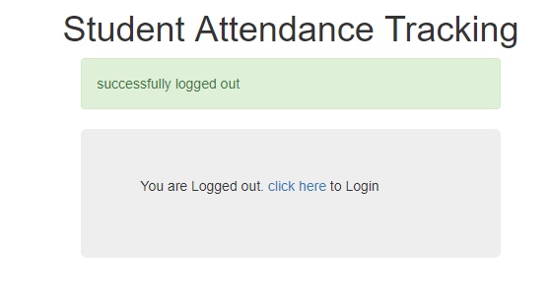

**Scan QR:**

As soon as the student opens the application it automatically re directs the student to the scan QR page, which allows the user to scan the QR code generated by the instructor. As soon as the QR gets scanned the feedback is displayed to the student staying that the QR has been scanned or not, if yes, then the attendance is marked.

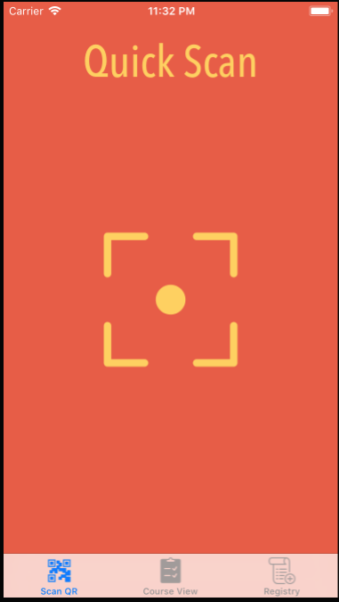

**Course View:**

This tab displays all the courses which the student has registered as displays the attendance of the student for that particular course on the particular date.

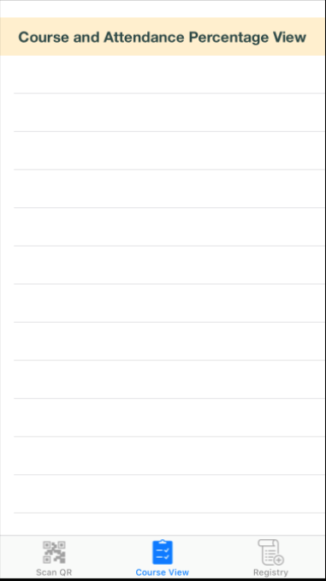

**Register Tab:**

In this tab the student is capable of registering to the new courses by just clicking on the registry tab on the screen which displays all the courses which are open for registration. These courses are displayed with the course name and also the CRN number of that particular course and on clicking these courses a student can register in to the course by just one click.

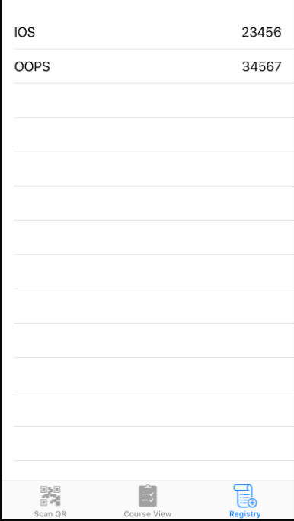

**USING THE SYSTEM**

Using the System